
This Photo by Unknown Author is licensed under CC BY-NC

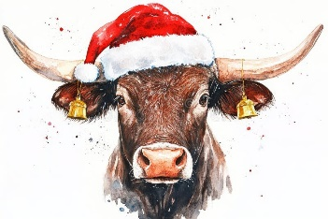
BRANTHAM BULL
PRE CHRISTMAS MENU
Available from December 2nd – 23rd December

TO START
Breaded mushrooms filled with chicken liver pate
***
Sweet potato & ginger soup (gf)
***
Smoked haddock & king prawn tomato gratin
***
Honey roasted ham, cheese & potato croquettes with chilli jam
***
This Photo by Unknown Author is licensed under CC BY-NC
Prawn & crayfish cocktail (gf)

FOR MAIN
Braised lamb shank in a mint burgundy gravy with mash & veg (gf)
***
Roast turkey with all the trimmings (gf)
***
Seabass with crushed new potatoes & honey mustard dressing (gf)
***
Venison & red wine pie with mash & vegetables
***
Beetroot, butternut squash, lentil & pesto wellington with salad (v/vg)

FOR SWEET
This Photo by Unknown Author is licensed under CC BY-NC
Bakewell tart with custard
***
Christmas pudding with brandy custard
***
White chocolate, raspberry & pistachio roulade with icecream (gf)
***
Toblerone & baileys cheesecake with icecream
***
Cheese & biscuits

2 COURSES £29 3 COURSES £37

£10 NON-REFUNDABLE deposit is required per person to confirm booking-if someone doesn’t turn up on the day full payment will be taken for their meal- must be pre-ordered at least two weeks before – please state any allergies or if gluten free on your pre orders-one bill per table – not available on a sunday

